**WEEK 4**

**Module 7 - Spring REST using Spring Boot 3**

**2.SPRING REST HANDS ON**

**Hello World RESTful Web Service**

**CODE:**

**pom.xml**

<project xmlns="http://maven.apache.org/POM/4.0.0"

xmlns:xsi="http://www.w3.org/2001/XMLSchema-instance"

xsi:schemaLocation="http://maven.apache.org/POM/4.0.0

http://maven.apache.org/xsd/maven-4.0.0.xsd">

<modelVersion>4.0.0</modelVersion>

<groupId>com.cognizant</groupId>

<artifactId>spring-learn</artifactId>

<version>0.0.1-SNAPSHOT</version>

<packaging>jar</packaging>

<name>spring-learn</name>

<description>Spring Boot Hello World REST Service</description>

<parent>

<groupId>org.springframework.boot</groupId>

<artifactId>spring-boot-starter-parent</artifactId>

<version>3.2.4</version>

<relativePath/>

</parent>

<properties>

<java.version>17</java.version> <!-- or 21 if you're using Java 21 -->

</properties>

<dependencies>

<dependency>

<groupId>org.springframework.boot</groupId>

<artifactId>spring-boot-starter-web</artifactId>

</dependency>

<dependency>

<groupId>org.springframework.boot</groupId>

<artifactId>spring-boot-starter-logging</artifactId>

</dependency>

<dependency>

<groupId>org.springframework.boot</groupId>

<artifactId>spring-boot-starter-test</artifactId>

<scope>test</scope>

</dependency>

</dependencies>

<build>

<plugins>

<plugin>

<groupId>org.springframework.boot</groupId>

<artifactId>spring-boot-maven-plugin</artifactId>

<version>3.2.4</version>

</plugin>

</plugins>

</build>

</project>

**src/main/java/com/cognizant/springlearn**

**SpringLearnApplication.java**

package com.cognizant.springlearn;

import org.springframework.boot.SpringApplication;

import org.springframework.boot.autoconfigure.SpringBootApplication;

@SpringBootApplication

public class SpringLearnApplication {

public static void main(String[] args) {

SpringApplication.run(SpringLearnApplication.class, args);

}

}

**src/main/java/com/cognizant/springlearn/controller**

**HelloController.java**

package com.cognizant.springlearn.controller;

import org.slf4j.Logger;

import org.slf4j.LoggerFactory;

import org.springframework.web.bind.annotation.GetMapping;

import org.springframework.web.bind.annotation.RestController;

@RestController

public class HelloController {

private static final Logger LOGGER = LoggerFactory.getLogger(HelloController.class);

@GetMapping("/hello")

public String sayHello() {

LOGGER.info("START: sayHello()");

String message = "Hello World!!";

LOGGER.info("END: sayHello()");

return message;

} }

**src/main/resources**

**application.properties**

server.port=8083

**OUTPUT:**

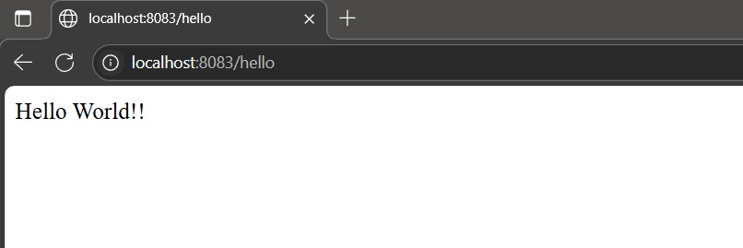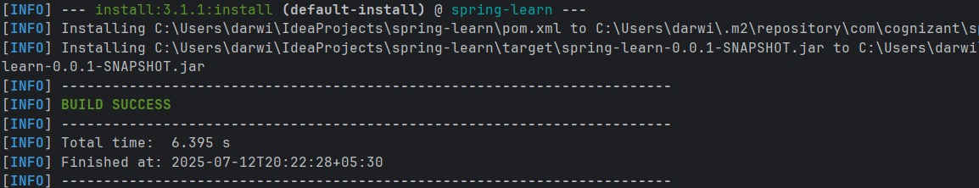

**REST - Country Web Service**

**CODE:**

**pom.xml**

<project xmlns="http://maven.apache.org/POM/4.0.0"

xmlns:xsi="http://www.w3.org/2001/XMLSchema-instance"

xsi:schemaLocation="http://maven.apache.org/POM/4.0.0

http://maven.apache.org/xsd/maven-4.0.0.xsd">

<modelVersion>4.0.0</modelVersion>

<groupId>com.cognizant</groupId>

<artifactId>spring-learn</artifactId>

<version>0.0.1-SNAPSHOT</version>

<properties>

<java.version>17</java.version>

</properties>

<dependencies>

<dependency>

<groupId>org.springframework</groupId>

<artifactId>spring-context</artifactId>

<version>6.1.5</version>

</dependency>

<dependency>

<groupId>org.springframework.boot</groupId>

<artifactId>spring-boot-starter-web</artifactId>

<version>3.2.4</version>

</dependency>

</dependencies>

<build>

<plugins>

<plugin>

<groupId>org.apache.maven.plugins</groupId>

<artifactId>maven-compiler-plugin</artifactId>

<version>3.10.1</version>

<configuration>

<source>17</source>

<target>17</target>

</configuration>

</plugin>

</plugins>

</build>

</project>

**src/main/java/com/cognizant/springlearn**

**SpringLearnApplication.java**

package com.cognizant.springlearn;

import org.springframework.boot.SpringApplication;

import org.springframework.boot.autoconfigure.SpringBootApplication;

@SpringBootApplication

public class SpringLearnApplication {

public static void main(String[] args) {

SpringApplication.run(SpringLearnApplication.class, args);

}

}

**src/main/java/com/cognizant/springlearn/controller**

**CountryController.java**

package com.cognizant.springlearn.controller;

import com.cognizant.springlearn.model.Country;

import org.springframework.context.ApplicationContext;

import org.springframework.context.support.ClassPathXmlApplicationContext;

import org.springframework.web.bind.annotation.RequestMapping;

import org.springframework.web.bind.annotation.RestController;

@RestController

public class CountryController {

@RequestMapping("/country")

public Country getCountryIndia() {

ApplicationContext context = new ClassPathXmlApplicationContext("country.xml");

Country country = (Country) context.getBean("country");

return country;

}

}

**src/main/java/com/cognizant/springlearn/model**

**Country.java**

package com.cognizant.springlearn.model;

public class Country {

private String code;

private String name;

public String getCode() {

return code; }

public void setCode(String code) {

this.code = code; }

public String getName() {

return name; }

public void setName(String name) {

this.name = name;

}

}

**src/main/resources**

**country.xml**

<?xml version="1.0" encoding="UTF-8"?>

<beans xmlns="http://www.springframework.org/schema/beans"

xmlns:xsi="http://www.w3.org/2001/XMLSchema-instance"

xsi:schemaLocation="http://www.springframework.org/schema/beans

http://www.springframework.org/schema/beans/spring-beans.xsd">

<bean id="country" class="com.cognizant.springlearn.model.Country">

<property name="code" value="IN"/>

<property name="name" value="India"/>

</bean>

</beans>

**src/main/resources**

**application.properties**

server.port=8083

**OUTPUT:**

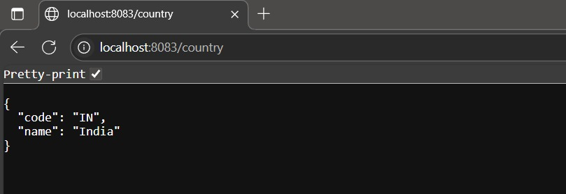

**In Controller:**

Uses ApplicationContext to load Spring XML.

Retrieves the country bean and returns it.

**Bean to JSON:**

Spring Boot uses Jackson (included in spring-boot-starter-web) to automatically convert Java objects into JSON.

**Headers in Dev Tools:**

Use Chrome → F12 → Network tab → click on /country → check Request Headers and Response Headers.

**Headers in Postman:**

Send GET to /country → go to "Headers" tab to inspect all headers.

**REST - Get all countries**

**CODE:**

**pom.xml**

<project xmlns="http://maven.apache.org/POM/4.0.0" ...>

<modelVersion>4.0.0</modelVersion>

<groupId>com.cognizant</groupId>

<artifactId>spring-learn</artifactId>

<version>0.0.1-SNAPSHOT</version>

<packaging>jar</packaging>

<name>spring-learn</name>

<parent>

<groupId>org.springframework.boot</groupId>

<artifactId>spring-boot-starter-parent</artifactId>

<version>3.2.4</version>

</parent>

<dependencies>

<dependency>

<groupId>org.springframework.boot</groupId>

<artifactId>spring-boot-starter-web</artifactId>

</dependency>

<dependency>

<groupId>org.springframework</groupId>

<artifactId>spring-context</artifactId>

</dependency>

<dependency>

<groupId>com.fasterxml.jackson.core</groupId>

<artifactId>jackson-databind</artifactId>

</dependency>

</dependencies>

<properties>

<java.version>17</java.version>

</properties>

</project>

**src/main/java/com/cognizant/springlearn**

**SpringLearnApplication.java**

package com.cognizant.springlearn;

import org.springframework.boot.SpringApplication;

import org.springframework.boot.autoconfigure.SpringBootApplication;

@SpringBootApplication

public class SpringLearnApplication {

public static void main(String[] args) {

SpringApplication.run(SpringLearnApplication.class, args);

}

}

**src/main/java/com/cognizant/springlearn/controller**

**CountryController.java**

package com.cognizant.springlearn.controller;

import com.cognizant.springlearn.model.Country;

import org.springframework.context.ApplicationContext;

import org.springframework.context.support.ClassPathXmlApplicationContext;

import org.springframework.web.bind.annotation.GetMapping;

import org.springframework.web.bind.annotation.RestController;

import java.util.List;

@RestController

public class CountryController {

@GetMapping("/countries")

public List<Country> getAllCountries() {

ApplicationContext context = new ClassPathXmlApplicationContext("country.xml");

List<Country> countries = (List<Country>) context.getBean("countryList");

return countries;

}

}

**src/main/java/com/cognizant/springlearn/model**

**Country.java**

package com.cognizant.springlearn.model;

public class Country {

private String code;

private String name;

public Country() {}

public Country(String code, String name) {

this.code = code;

this.name = name; }

public String getCode() {

return code; }

public void setCode(String code) {

this.code = code; }

public String getName() {

return name; }

public void setName(String name) {

this.name = name;

}

}

**src/main/resources**

**country.xml**

<beans xmlns="http://www.springframework.org/schema/beans"

xmlns:xsi="http://www.w3.org/2001/XMLSchema-instance"

xsi:schemaLocation="

http://www.springframework.org/schema/beans

http://www.springframework.org/schema/beans/spring-beans.xsd">

<bean id="in" class="com.cognizant.springlearn.model.Country">

<property name="code" value="IN"/>

<property name="name" value="India"/>

</bean>

<bean id="us" class="com.cognizant.springlearn.model.Country">

<property name="code" value="US"/>

<property name="name" value="United States"/>

</bean>

<bean id="jp" class="com.cognizant.springlearn.model.Country">

<property name="code" value="JP"/>

<property name="name" value="Japan"/>

</bean>

<bean id="de" class="com.cognizant.springlearn.model.Country">

<property name="code" value="DE"/>

<property name="name" value="Germany"/>

</bean>

<bean id="countryList" class="java.util.ArrayList">

<constructor-arg>

<list>

<ref bean="in"/>

<ref bean="us"/>

<ref bean="jp"/>

<ref bean="de"/>

</list>

</constructor-arg>

</bean>

</beans>

**src/main/resources**

**application.properties**

server.port=8083

**OUTPUT:**

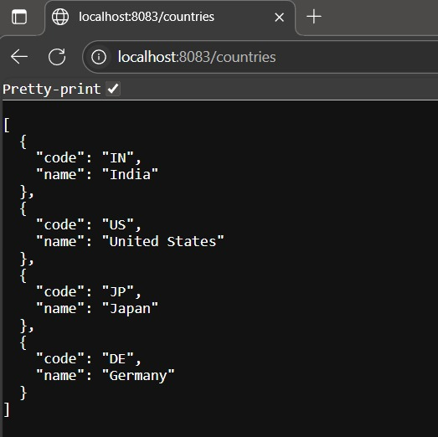

**REST - Get country based on country code**

**CODE:**

**pom.xml**

<project xmlns="http://maven.apache.org/POM/4.0.0"

xmlns:xsi="http://www.w3.org/2001/XMLSchema-instance"

xsi:schemaLocation="http://maven.apache.org/POM/4.0.0 https://maven.apache.org/xsd/maven-4.0.0.xsd">

<modelVersion>4.0.0</modelVersion>

<groupId>com.cognizant</groupId>

<artifactId>spring-learn</artifactId>

<version>1.0</version>

<packaging>jar</packaging>

<name>spring-learn</name>

<description>Spring Learn REST Example</description>

<parent>

<groupId>org.springframework.boot</groupId>

<artifactId>spring-boot-starter-parent</artifactId>

<version>3.2.4</version>

<relativePath/> <!-- lookup parent from repository -->

</parent>

<properties>

<java.version>17</java.version>

</properties>

<dependencies>

<dependency>

<groupId>org.springframework.boot</groupId>

<artifactId>spring-boot-starter-web</artifactId>

</dependency>

<dependency>

<groupId>org.springframework.boot</groupId>

<artifactId>spring-boot-starter-test</artifactId>

<scope>test</scope>

</dependency>

<dependency>

<groupId>org.springframework</groupId>

<artifactId>spring-context</artifactId>

</dependency>

<dependency>

<groupId>org.projectlombok</groupId>

<artifactId>lombok</artifactId>

<optional>true</optional>

</dependency>

</dependencies>

<build>

<plugins>

<plugin>

<groupId>org.springframework.boot</groupId>

<artifactId>spring-boot-maven-plugin</artifactId>

</plugin>

</plugins>

</build>

</project>

**src/main/java/com/cognizant/springlearn**

**SpringLearnApplication.java**

package com.cognizant.springlearn;

import org.springframework.boot.SpringApplication;

import org.springframework.boot.autoconfigure.SpringBootApplication;

@SpringBootApplication

public class SpringLearnApplication {

public static void main(String[] args) {

SpringApplication.run(SpringLearnApplication.class, args);

}

}

**src/main/java/com/cognizant/springlearn/controller**

**CountryController.java**

package com.cognizant.springlearn.controller;

import com.cognizant.springlearn.model.Country;

import com.cognizant.springlearn.service.CountryService;

import org.springframework.beans.factory.annotation.Autowired;

import org.springframework.web.bind.annotation.*;

@RestController

public class CountryController {

@Autowired

private CountryService countryService;

@GetMapping("/countries/{code}")

public Country getCountry(@PathVariable String code) throws Exception {

return countryService.getCountry(code);

}

@GetMapping("/countries")

public List<Country> getAllCountries() {

ApplicationContext context = new ClassPathXmlApplicationContext("country.xml");

return context.getBean("countryList", List.class);

}

}

**src/main/java/com/cognizant/springlearn/model**

**Country.java**

package com.cognizant.springlearn.model;

public class Country {

private String code;

private String name;

public Country() {}

public Country(String code, String name) {

this.code = code;

this.name = name;

}

public String getCode() {

return code;

}

public void setCode(String code) {

this.code = code;

}

public String getName() {

return name;

}

public void setName(String name) {

this.name = name;

}

}

**src/main/resources**

**country.xml**

<beans xmlns="http://www.springframework.org/schema/beans"

xmlns:xsi="http://www.w3.org/2001/XMLSchema-instance"

xsi:schemaLocation="http://www.springframework.org/schema/beans

http://www.springframework.org/schema/beans/spring-beans.xsd">

<bean id="country1" class="com.cognizant.springlearn.model.Country">

<property name="code" value="IN"/>

<property name="name" value="India"/>

</bean>

<bean id="country2" class="com.cognizant.springlearn.model.Country">

<property name="code" value="US"/>

<property name="name" value="United States"/>

</bean>

<bean id="countryList" class="java.util.ArrayList">

<constructor-arg>

<list>

<ref bean="country1"/>

<ref bean="country2"/>

</list>

</constructor-arg>

</bean>

</beans>

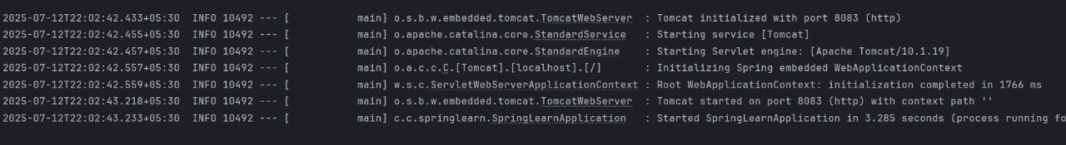**OUTPUT:**